SSN COLLEGE OF ENGINEERING, KALAVAKKAM
DEPARTMENT OF COMPUTER SCIENCE & ENGINEERING
Internet Programming Lab – CS6512
Programming Assignment 25 – Internal Mark Calculation Application using PHP
________________________________________________________________________

Develop Internal Mark Calculation system in PHP that facilitates a student to view the internal marks for a particular subject and a faculty to perform the operations given in the following snapshot. Create the following tables. During every operation, subject code has to be retrieved from the faculty. Faculty inserts one record at a time using formcontrols. 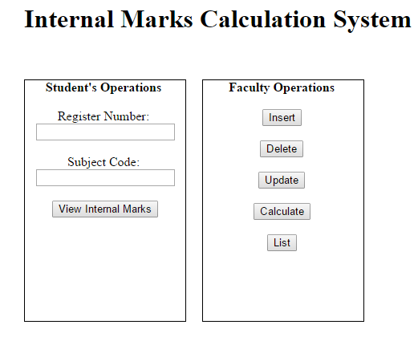
CS6501
Reg.No | Name | UT1 | UT2 | UT3 | IM
CS6502
Reg.No | Name | UT1 | UT2 | UT3 | IM
CS6503
Reg.No | Name | UT1 | UT2 | UT3 | IM

